**CSIS 4495 – Applied Research Project**

**What’s In My Fridge**

**By**

**Kosha Paresh Raval**

**300324116**

**Section 1**

**What’s in my Fridge - “Cooking with all you have”.**

**Statement of the Problem**

In a perfect world we would be utilizing everything that we purchased from the grocery stores and never waste any food or money. We would remember to buy everything that is required and have all the ingredients while cooking a special recipe. The user is also able to save the recipe and re-create it.

But in reality, when we go to a grocery store such as Walmart or Superstore there are endless options for what we want and we generally tend to forget what we actually need to buy. We watch tons of YouTube recipes and note down all the ingredients on a piece of paper or take a picture of it and end up misplacing them. There are many apps in market which help with this problem individually but not all at once, means the user has to download multiple apps and end up using none.

The existing applications makes user do majority of the work wherein they have to select the items available to them via a predetermined list from which the app will then provide a recipe. The idea is to eliminate this lengthy process and have the app do that for them. When the users do their groceries, they will click a picture of the receipt and upload it on the app which will create a list of items that are there in their fridge and suggest recipes based on the new list that is created. The list of items will be sorted with respect to expiration date, name and category. In addition to this the app would give them a notification when the food is about to expire and on expiry the food will be added automatically to the shopping list. The second major feature that I want to implement is that when they click a screenshot of ingredients from a book or a YouTube description box, they can upload this to the app and it will make a list of these ingredients which they can then choose to add in the shopping list. The users will also have an option of sharing their recipe creations and save them for future references.

**Significance of the study**

As an international student moving to a new country and managing everything on our own is a bit of difficult along with cooking and doing groceries, we tend to forget what’s in the fridge and certainly are not able to use all the ingredients.

This app would also help people who are working and don’t have time to think on what they will cook for dinner tonight and end up ordering food online.

Additionally, this will also aid a family where both parents are working & need to do the grocery, keep track of all the items, plus have something new for the kids lunches and family dinners.

With the development of this application, I want to further understand food waste management systems and help users make a contribution no matter how small.

**Proof of progress**

Technologies: React-Native

Database: Firebase

|  |  |  |  |
| --- | --- | --- | --- |
| Reports - Dates | Activity | Description | Status |
| Report 1: Oct 01 | Set up Environment. | Install required software’s and download required Libraries. | Done |
| Application Architecture and Design | Defining all the required screens for the application.  Design UML diagrams for smooth navigation of the application. | Done |
| Database Schema | Setup Firebase Connectivity.  Define database schema for the application and create tables and add demo data. | Done |
| UI Designing | Design Flow of the UI Screens. | Done |
| UI Development | Complete 20% of Functionality of screens  Document process till date. | Done |
| Mid-Term: Oct 22 | Research | User Registration and Login using Firebase | Done |
| UI Development | Complete 50% of Functionality of screens | Done |
| Mid-Term Report | Document process till date.  Prepare the Oral Presentation. | Done |
| Report 2: Nov 12 | UI Development | Complete 75% of Functionality of screens  Document process till date. | Done |
| Testing | Testing the integration of the components and screens. | Done |
| Report 3: Dec 03 | UI Development | Conversion of Image to Text to List. | Not Implemented |
| UI Development | Complete 100% of Functionality of screens  Document process till date. | Done |
| Testing | Testing the integration of the components and screens. | Done |
| Deployment of application. |  | Done |
| Final Report: Dec 08 | Document the Final Report and Prepare final presentation. |  | Done |

**Application design and UI Screenshots**

Splash screen:

This is the on boarding screen of the application which means when the application is installed for the first time from App Store the user see 3 images in form of a slide show, giving idea about the what the application is about.

There are two small buttons at the bottom in the either corner of the screen. The “SKIP” button will take the user directly to the Login Screen of the application. The “Next” button will slide to the next Image.

This is implemented using the On-Boarding Library by react native.

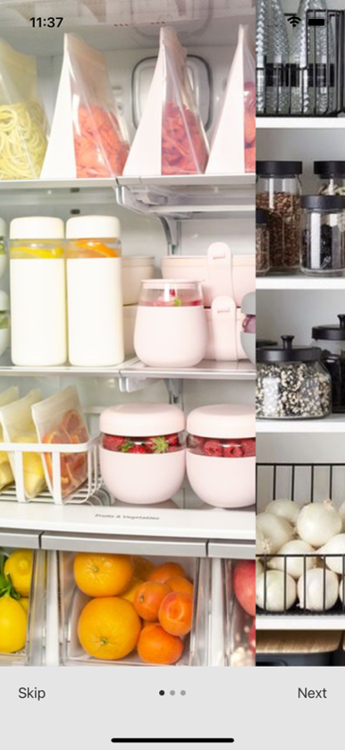 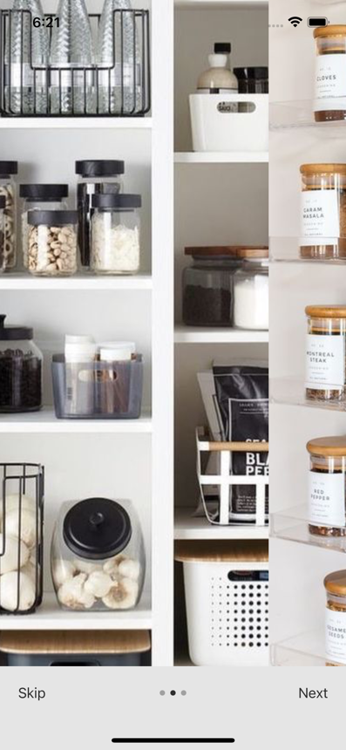 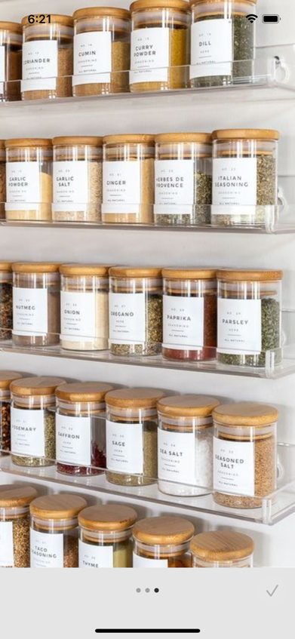

Login Screen:

The Login screen of the application allows the new user to sign up using sign-up form which can be accessed by clicking on the sign-up button. Returning users can enter their email address and password and click on the sign in button to log into the application.

For implementing third-party logins such as login with google or Facebook could not be implemented as Apple has updated their policies since April 2020. To provide third-party login you need to enrol into Apple developer program for using Apple ID.

auth Library provided by firebase is used for authenticating users.

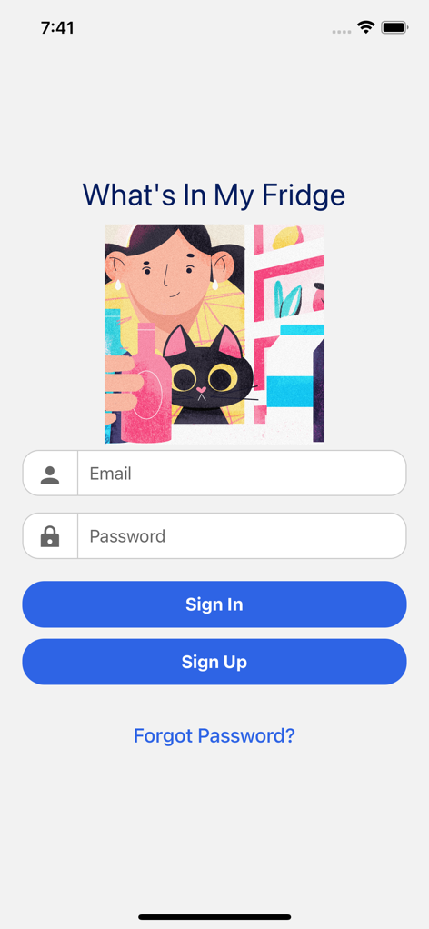 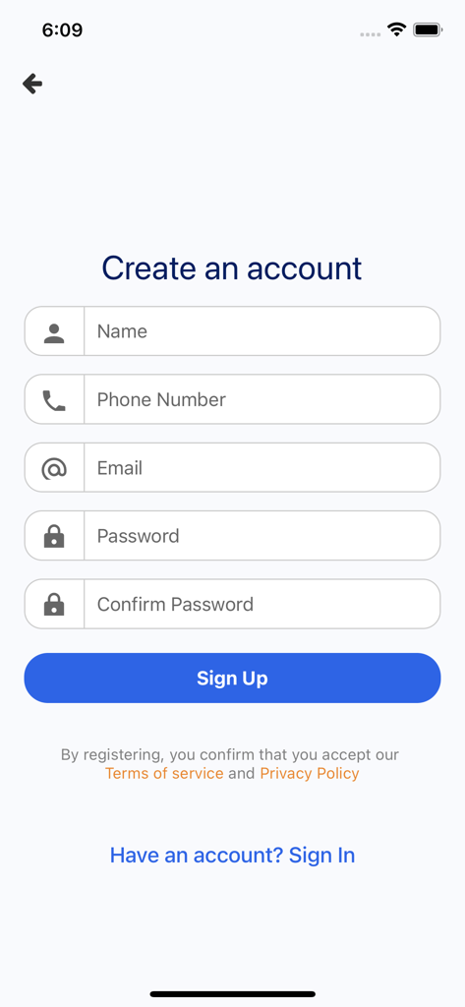

Registration screen:

The user will input personal details such as full name phone number email and password to set up an account for the application and will submit. Following this the user will be led to the home page. The values will be stored in the database.

The Registration Screen will help new users created their account using the email address and password. This will be stored in firebase authentication and when the user has completed registration on click sign up button the user will be redirected to the login screen.

Home Screen:

This is the main screen of the application the user can navigate through whole application from here. It will have a bottom navigation to move through the application. The screen will appear blank for a first-time user as they would have not uploaded any receipt or image of ingredients & as for the other users, they will see their current inventory of the fridge. The camera option will have two choices either click a new picture or select a picture from the gallery. The items of the pantry will have information such as when the item was purchased when it will expire and how to check the box to select whether the item was used or it has expired.

The Inventory screen will show all the Items that the user has currently in their fridge. This list will be updated when the user will upload new image receipt through the Add Receipt Screen. The list is in form of a card for each item. Each card will have information about the product name purchase date expiry date category and a button to mark it as used.

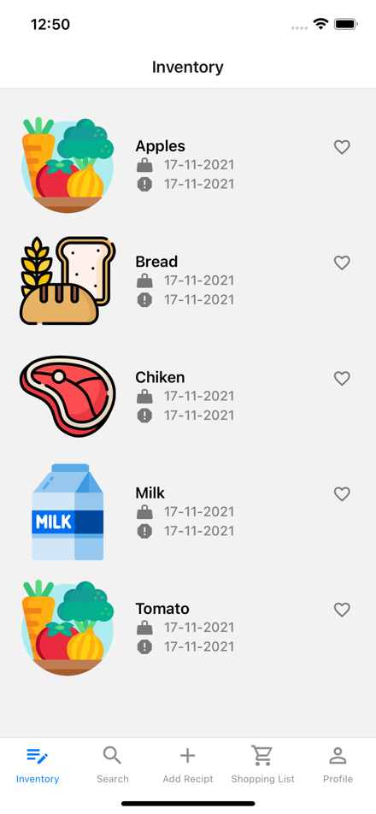 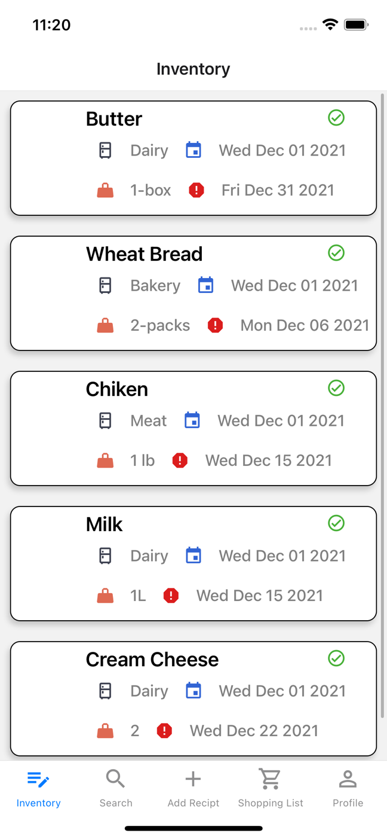

The screen on left is first design draft of the screen and the data displayed on that screen was static data. The screen on the right shows the data from the fire base database and with respect to the user that has logged in.

Recipe Screen:

The screen will display recipes with respect to the inventory present in the fridge that is the home screen and these recipes be displayed by using an API. The user will have the option of recognizing the recipes into two sections one will be bookmarked and the other will be tried and tested.

The Search Recipe Screen will allow the user to search different recipes by entering keywords in the search input field. By default, it will show 10 random recipes.

The screen is designed inside a scroll view. When Do use are most click on the recipe to view detailed information about the recipe which will open in a new screen called recipe detail screen.

API for finding recipes: <https://developer.edamam.com/?gclid=CjwKCAiAm7OMBhAQEiwArvGi3H4XBx8Rz1UFYMkuRbakMXTMt6ItqfJSmj0kPaZo9HywoUP1xxr68hoCYCcQAvD_BwE>

This is the recipe search screen of the application with the user again type in the search item in the green search bar and click there will be recipes displayed based on the ingredient that has been entered in the search bar. 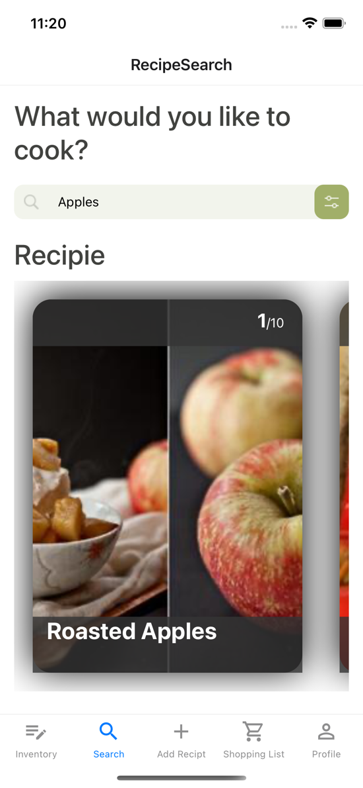

When you click on a particular recipe below first screen on the left is displayed with information about that recipe. If the user lives the recipe and wants to see you for future references then by clicking add to wish list button on the left screen the heart will turn to green when it is complete and the screen on the right is the result of screen.

The favourite recipe list is viewed from the profile screen by clicking on your favourites.

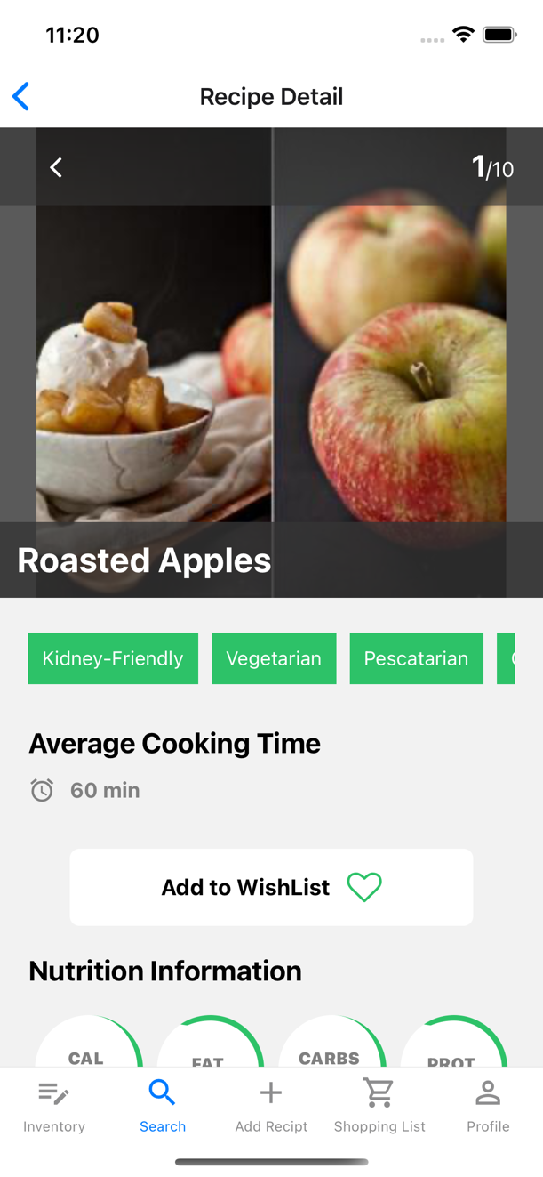 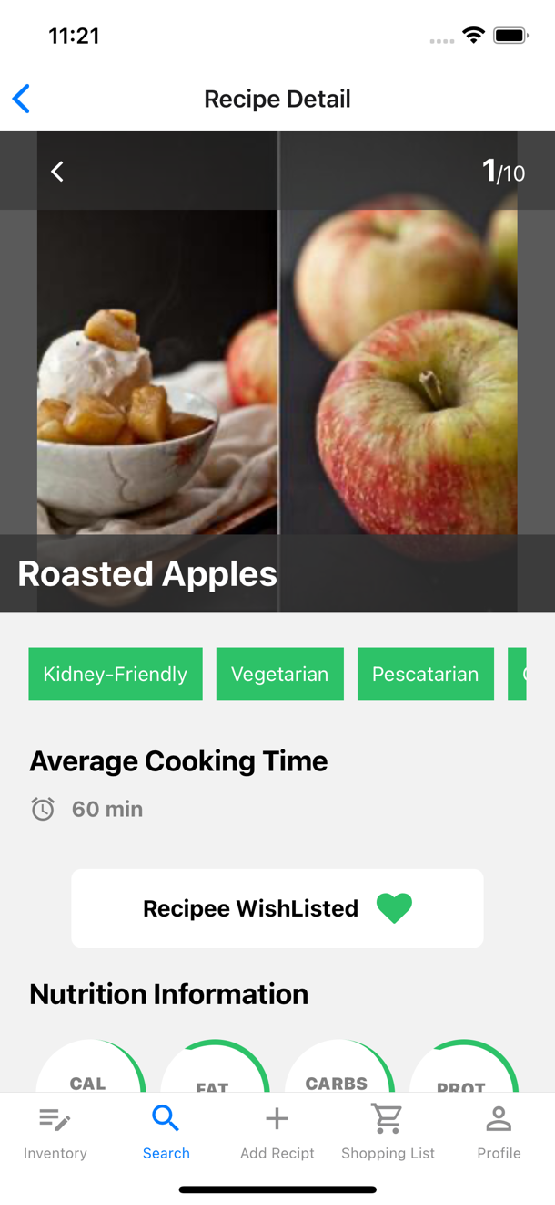

Shopping list screen:

The screen will show the items that needs to be refilled into the pantry or the fridge. When an item is expired or is consumed by the user, they will check the appropriate box and it will be added to the shopping list.

When the items that have been used by the user or are expired then those items will be added into the shopping list. The user will be provided with a delete button to remove the item from the shopping list.

Delete functionality is implemented by using mobile gestures of swiping left and then clicking on the delete button.

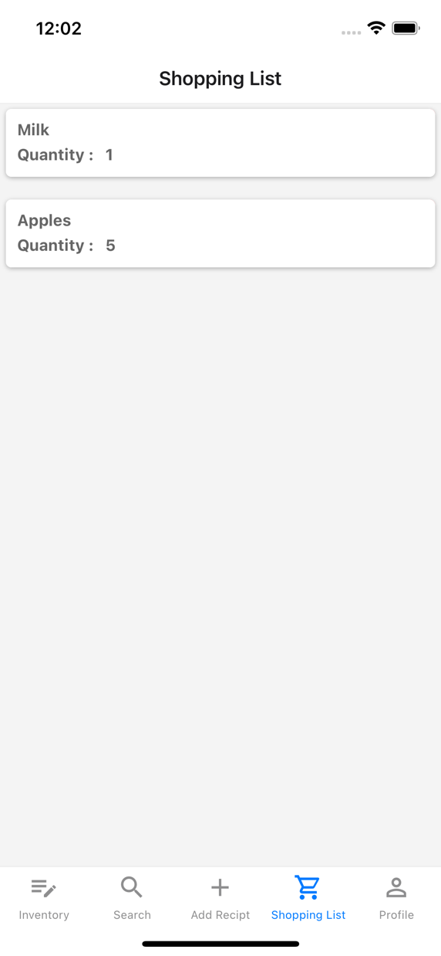 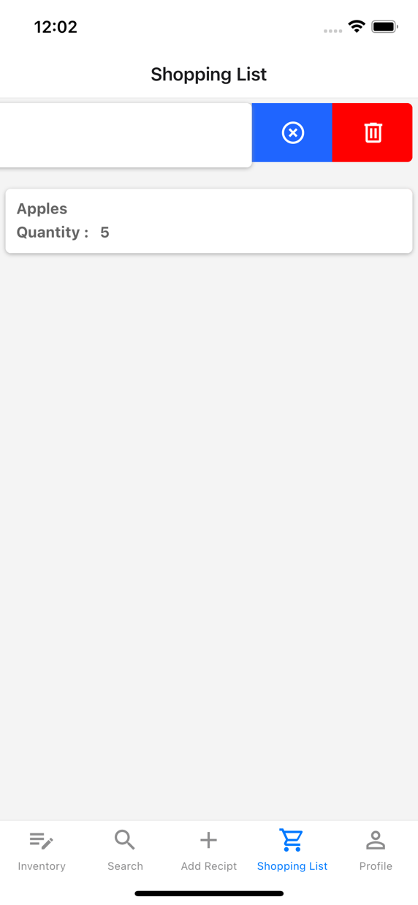

Profile Screen:

This is the profile screen of the application which will give the information about the user. The “your favourite” button will open all the favourites marked by the user from the recipe detailed screen.

The “edit profile” button will allow the user to update the details using and from. When the user wants to change the profile picture an option menu from the bottom of the screen called the “Bottom-Slider” will come up and once the user has selected the image the slider will close down automatically.

The “Logout” button will allow the user to sign out from the application.

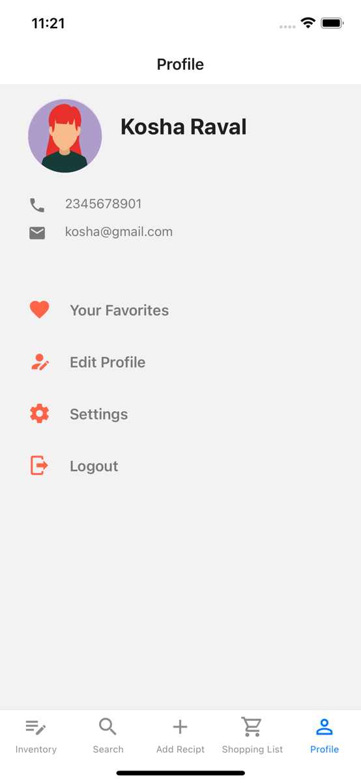 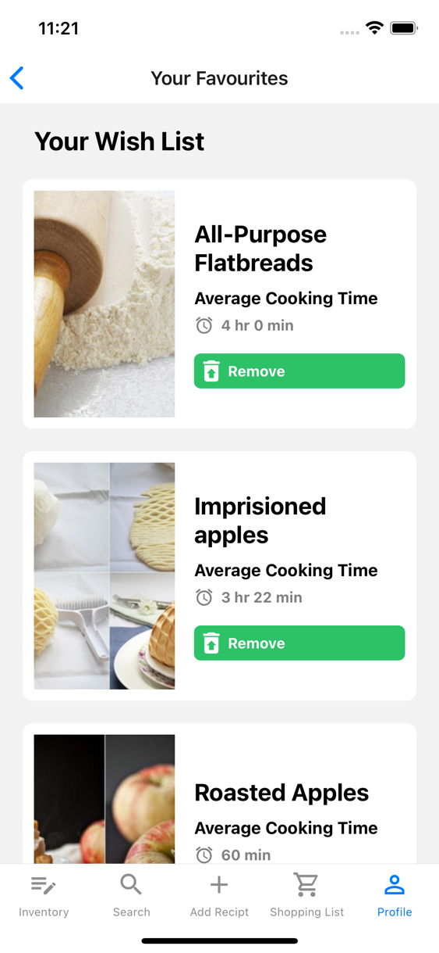

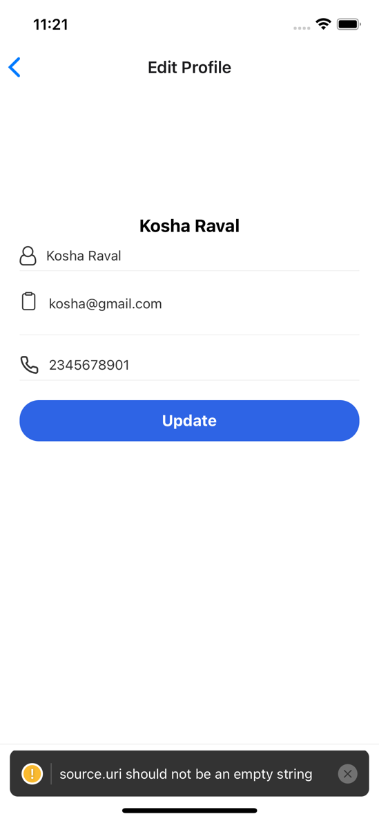

Add New Receipt Screen:

This screen was supposed to allow the user to either to click a picture of the receipt or select an image from the gallery. Below images show how the user can select an image from the phone gallery. Since this is an emulator the Camera function could not be tested. The Buttons on the screen that show multiple options are called the Action- Buttons.

**Conversion of image to text to a list**

The library used to for converting image into text is as follows:

**react-native-tesseract-ocr. $ npm i react-native-tesseract-ocr –save**

This Library works on lower version of @react and I was unable to install this for my project and the Library has not been developed for iOS. The current version of react has many depending libraries and it is not advised to degrade the version. As most of the designing and functionality in react native is based on using and implementing different libraries this feature is not implemented.

As this feature was not implemented the user is provided with a small form for uploading items in the Inventory.

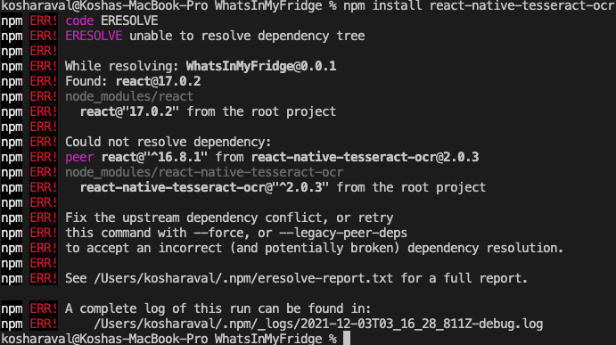

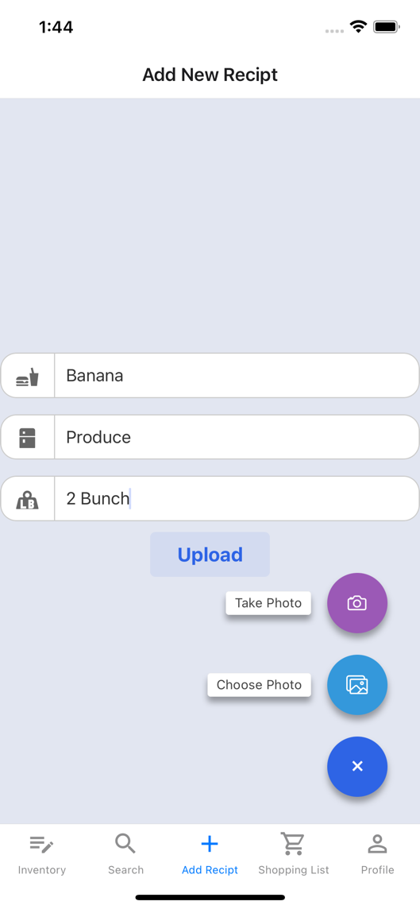 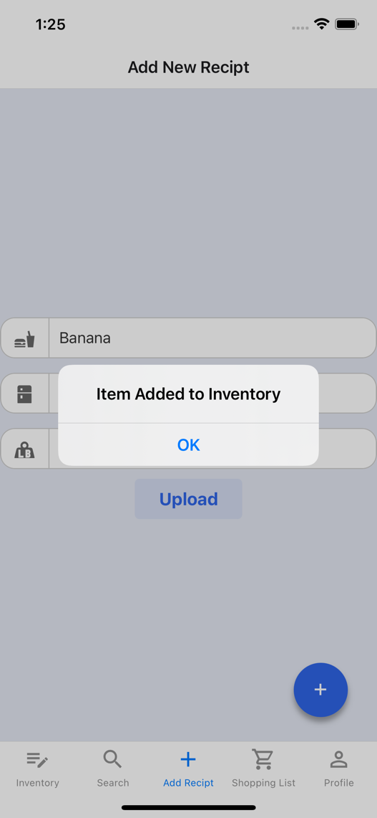

**Setting Up Development Environment**

The software requirement for development of the mobile application was done on a Mac machine. All the steps were followed by referring to the official doc’s pages of the software. The order in which the software’s were installed for React-Native app development is as follows:

1. Install Node js version 12 or higher
   1. Go to: <https://nodejs.org/en/download/>
   2. Download macOS Intaller(.pkg)
2. Install Homebrew
   1. Go to: <https://brew.sh/>
   2. Copy the command shown in the below screenshot and paste it on the Terminal for installing brew on the Mac machine.

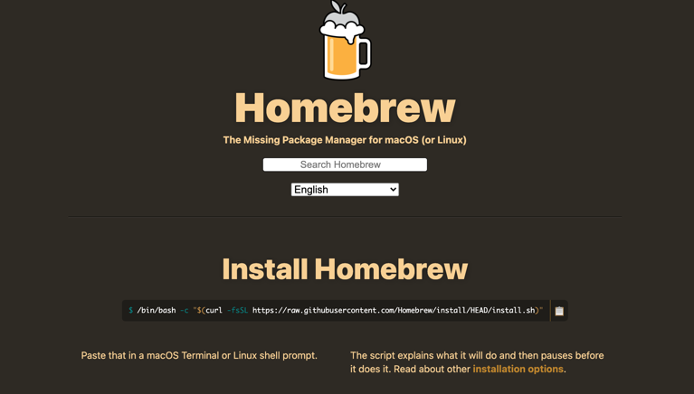

1. Install Expo CLI
   1. Go to: <https://reactnative.dev/docs/environment-setup>
   2. Follow the steps from the Expo CLI QuickStart Tab as I was new to mobile development.
   3. Note: Install Expo CLI globally. Use **sudo** as pre-fix of command to avoid access denials.

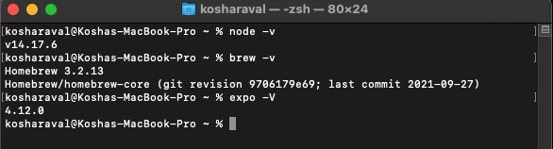

1. Creating React Native CLI project:
   1. Install Yarn
   2. Install CocoaPods for ios
   3. Create project using npx command

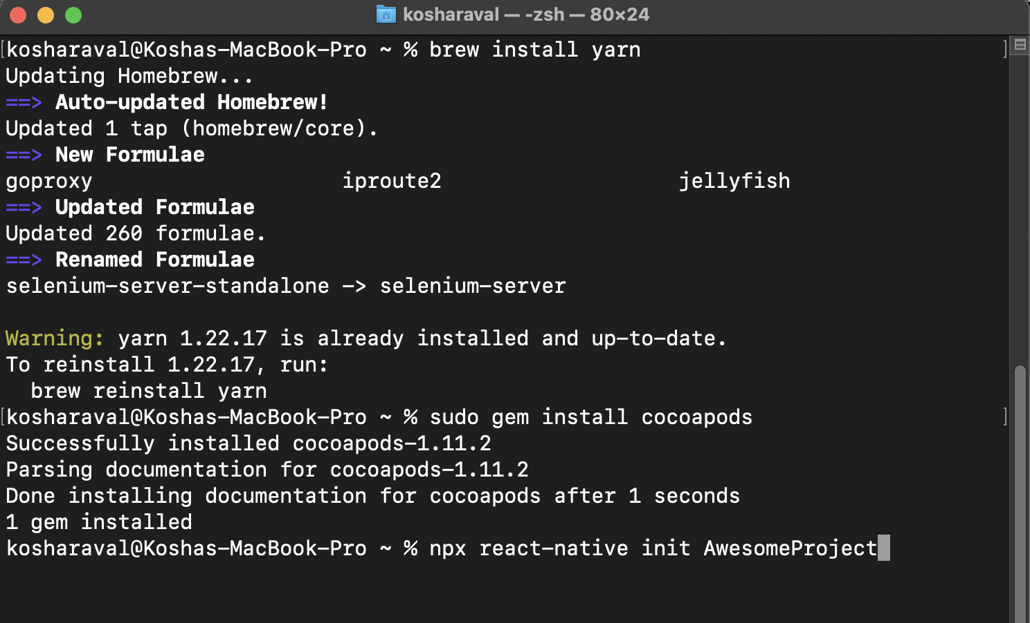

1. Code Editor: Visual Code
   1. Go to: <https://code.visualstudio.com/download>
   2. After Installation add the following extension for easy development.
      1. React Native Tools by Microsoft.
      2. React-Native/React/Redux by Equimper
2. Configure the iOS emulator
   1. Install Xcode from the App Store.
   2. After installation run Xcode and go to System Preferences => Locations => Select the latest version of Xcode in the Command Line Tools Dropdown.
   3. Go to Xcode => Open Developer Tools => Simulator.
3. Configure the Android emulator
   1. Install Android studio and setup the android studio with default settings.
   2. Go to Configure Menu => Android SDK tab => Select latest or second latest version from SDK Platforms Tab;
   3. In SDK tools, Android SDK Build-Tools 30-rc2, Android Emulator, Android SDK Platform Tools and Intel x86 Emulator Accelerator should be selected.
   4. These steps need to be followed by the Mac users only. Go to: https://docs.expo.dev/workflow/android-studio-emulator/
   5. Open Terminal and Add this to bash and zsh
      1. cd /bin -> ls (list all the file in bin)
      2. open bash, copy paste both commands
      3. export ANDROID_SDK=/Users/kosharaval/Library/Android/sdk
      4. export PATH=/Users/kosharaval/Library/Android/sdk/platform-tools:$PATH
   6. Go to home in Terminal by cd ~
   7. Run Android Debug Bridge version 1.0.41 by using command: adb

**Firebase Connectivity with Application**

I logged in to fire base using my Gmail account. For connecting my application to the file BTW the first step was to click on create a project button as shown in the below figure

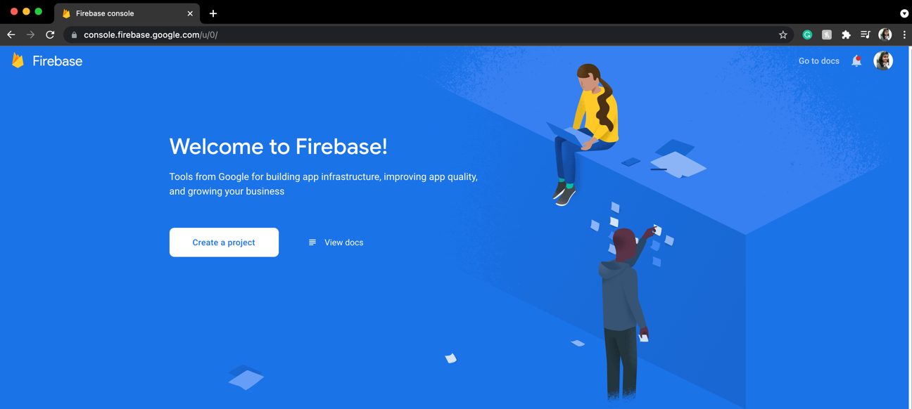

You can give any names that you want to the project that you are creating in firebase, it does not have be the same name as the application that you creating in React-Native. But to maintain that level of consistency I decided to name my fire base database project as same as my application i.e. WhatInMyFridge.

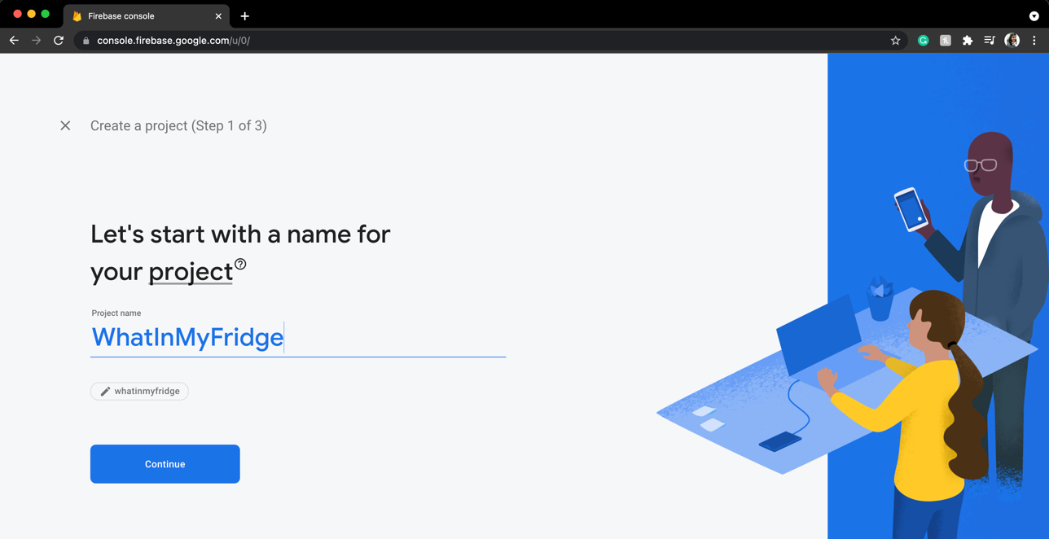

As this was just a development project and I was using fire bees to store where is small amount of detail I did not select the Google analytics option and proceeded forward with creating the firebase database project

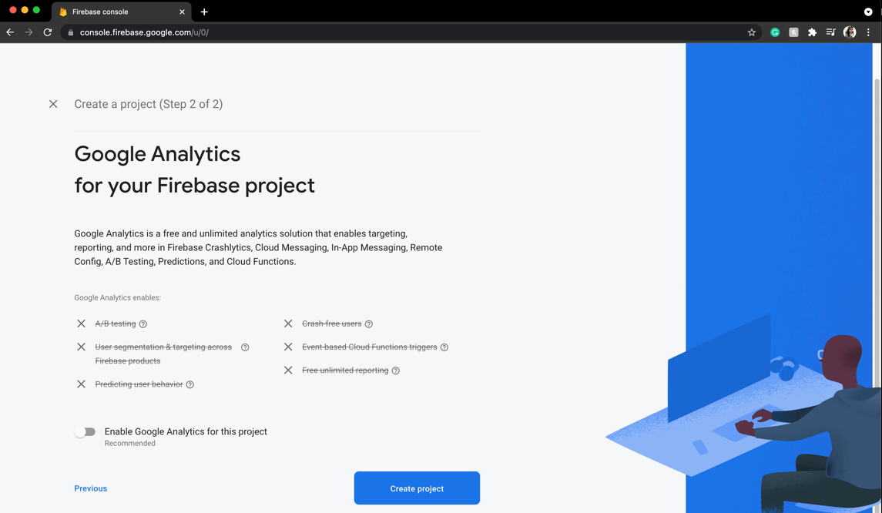

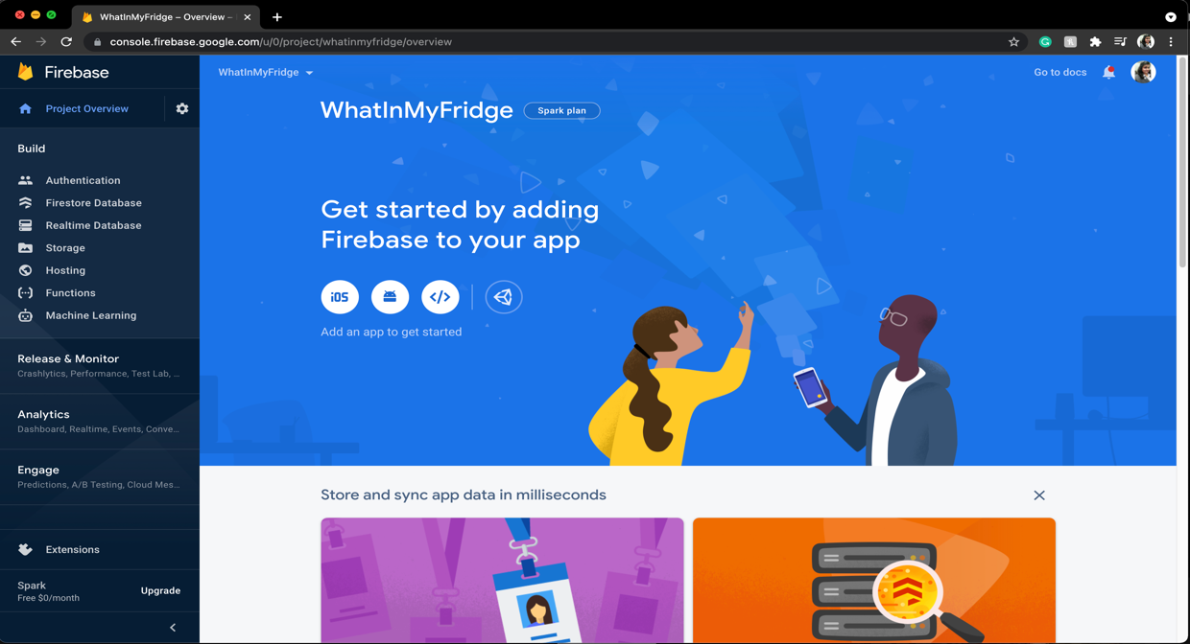

In, the next two steps I have add react native application to the firebase database project that I just created.

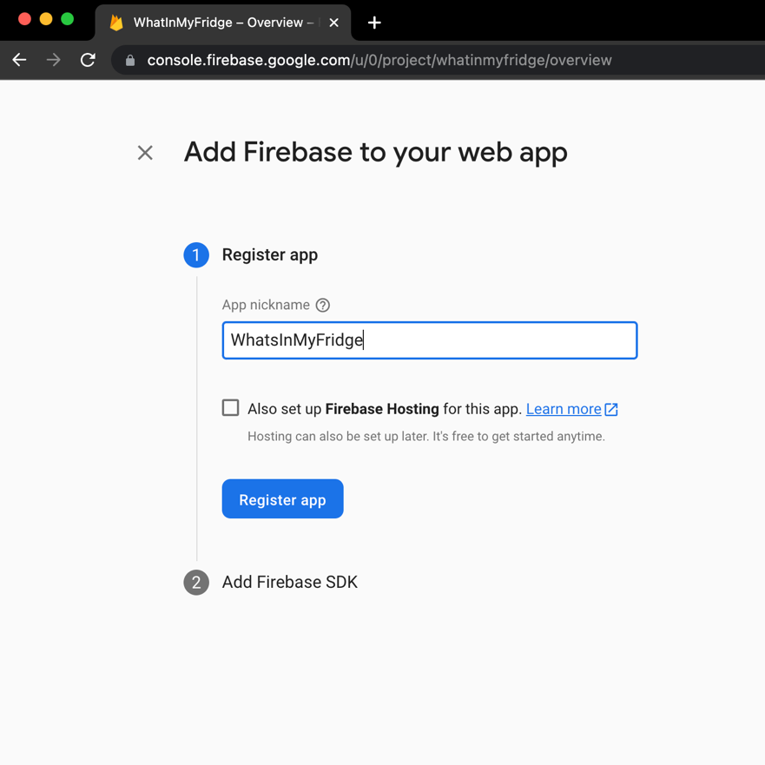

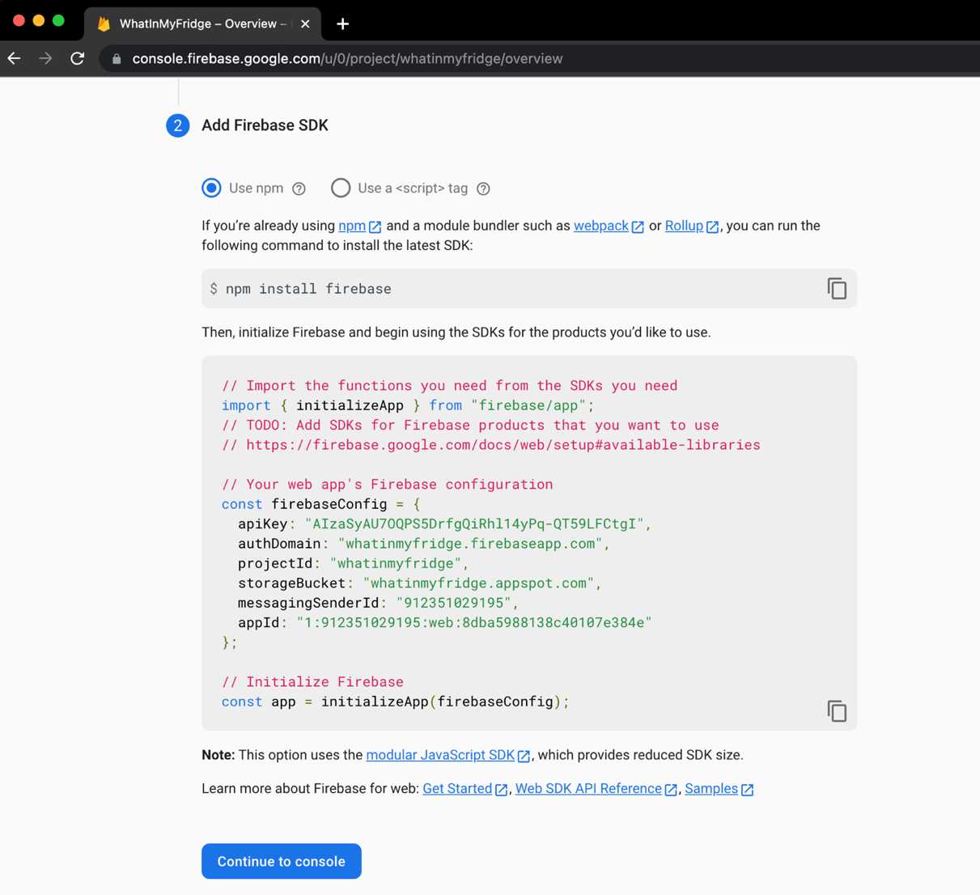

List of Libraries used in Application

|  |  |
| --- | --- |
| Use of dependencies installed | Command |
| These Dependencies were installed for creating navigation for screens in form of stack and tab | npm install @react-navigation/native |
| npm install react-navigation-stack |
| npm install @react-navigation/material-bottom-tabs react-native-paper react-native-vector-icons |
| Dependency that helps in adding items such as hamburger icon, trash icon, profile icon | npm install --save react-native-ico-material-design |
| Dependence he for creating an introduction page that is splash screen | npm i react-native-onboarding-swiper |
| Firebase is dependencies  Authentication  Add/Update/Delete/Fetch Data from firebase | npm install --save @react-native-firebase/app  npm install @react-native-firebase/auth  npm install @react-native-firebase/firestore |
| For storing data on the local disk of the device. | npm install @react-native-async-storage/async-storage |
| For Implementing scroll up screens on profile page | npm install reanimated-bottom-sheet |
| For actions buttons for example: more options as button are shown on click on a button and disappear on click of the same button | npm i react-native-action-button --save  (<https://www.npmjs.com/package/react-native-action-button>) |
| For selecting an image from the gallery or camera. | npm i react-native-image-crop-picker  (https://github.com/ivpusic/react-native-image-crop-picker) |
| For Using CSS style sheet in react native | <https://styled-components.com/docs/basics#installation> |
| Used this documentation for updating the Existing libraries to the latest version. | https://www.carlrippon.com/upgrading-npm-dependencies/ |

Software Design architecture

Application Navigation

React native has different types of navigation for this project I have used Bottom Tab navigation and Stack navigation. Stack navigation means the user has to come back to the previous screen in order to open another screen. In tab navigation whichever tab is selected that tab’s base screen is opened.

There are 2main stacks for the application i.e. the Auth-Stack and the App-Stack. The user 1st sees the Auth-Stack which contain the Welcome Screen. On successful login the user is shown information using the App-Stack

Welcome screen is using the stack navigation which means screens are pushed and popped from the stack.

The home screen has tab navigation which has five screens as mentioned below.

On the search screen there are two screens stacked that is the search recipe screen and recipe detail screen. Base Screen: Search Recipe Screen.

On the profile screen 3 screens are stacked i.e., profile screen favourite screen and edit profile screen. Base Screen: Profile Screen.

The navigation of the application is described as:

1. Auth-Stack
   1. Welcome screen
      1. On loading screen
      2. Login screen
      3. Registration screen
2. App-Stack
   1. Home Screen
      1. Inventory screen
      2. Search screen
         1. Search Recipe Screen
         2. Recipe detail Screen
      3. Add receipt screen
         1. Upload Image Screen
      4. Shopping list screen
      5. Profile screen
         1. Favourites screen
            1. Recipe detail screen
         2. Edit Profile screen
            1. Upload images Slider

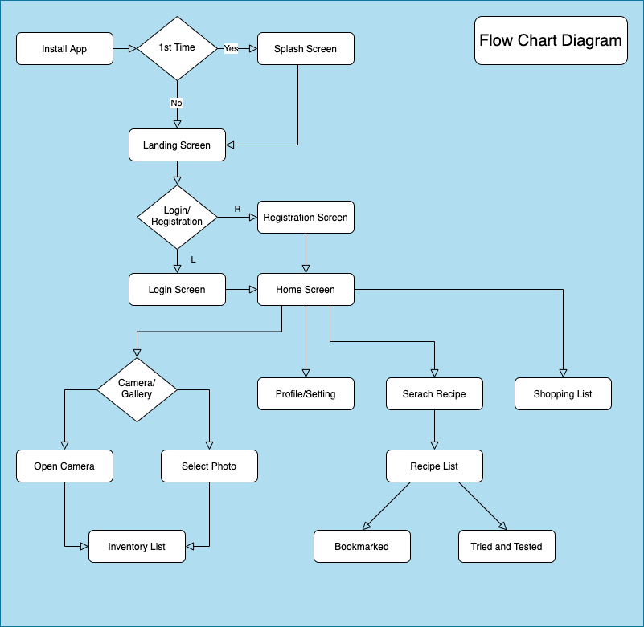

Database Schema

The application will have 5tables: User, Inventory, Category, Recipe Info, Shopping List. Below is the ER-diagram.

|  |  |  |
| --- | --- | --- |
| Table Name | Column Name | Datatype |
| Users | FullName | String |
| Phone | Number |
| Email | String |
| Password | String |
| UserId | String |
| ProfilePic | String |
| Created On | Date |
| UpatedOn | Date |
| Category | CategoryName | String |
| CatrgoryIcon | String |
| Inventory | ItemName | String |
| PurchaseDate | Date |
| CategoryName | String |
| ExpiryDate | Date |
| ExpiredFlag | Boolean |
| UserId | String |
| ItemIcon | String |
| Quantity | Number |
| ShoppingList | ItemName | String |
| Quantity | Number |
|  | UserId | String |

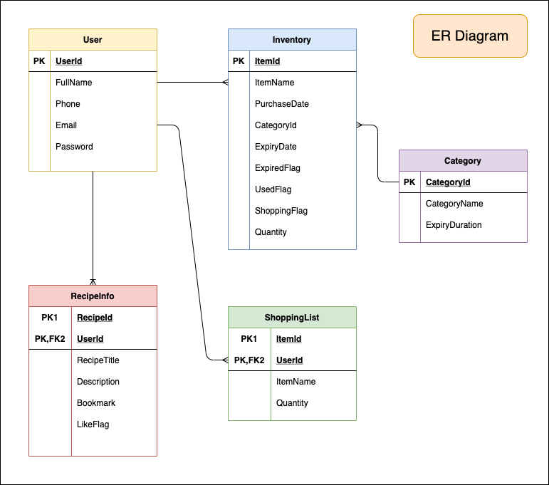

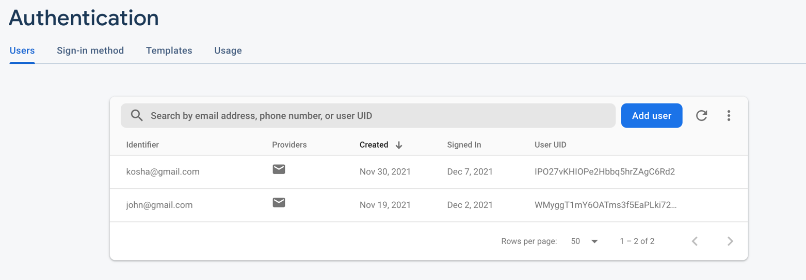

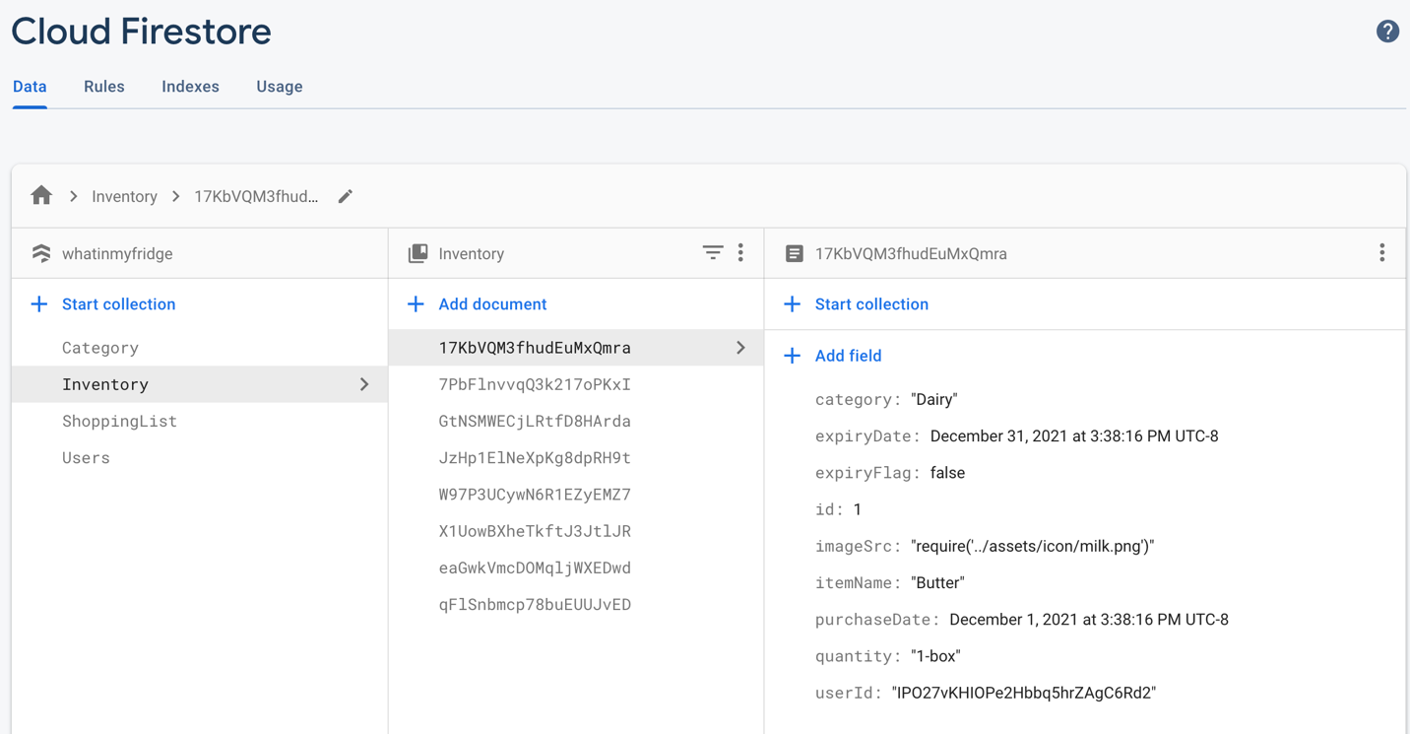

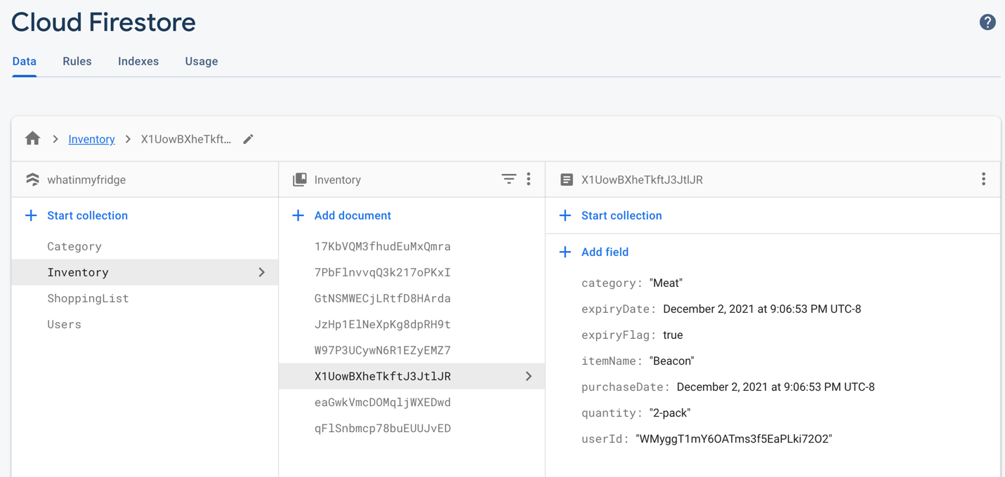

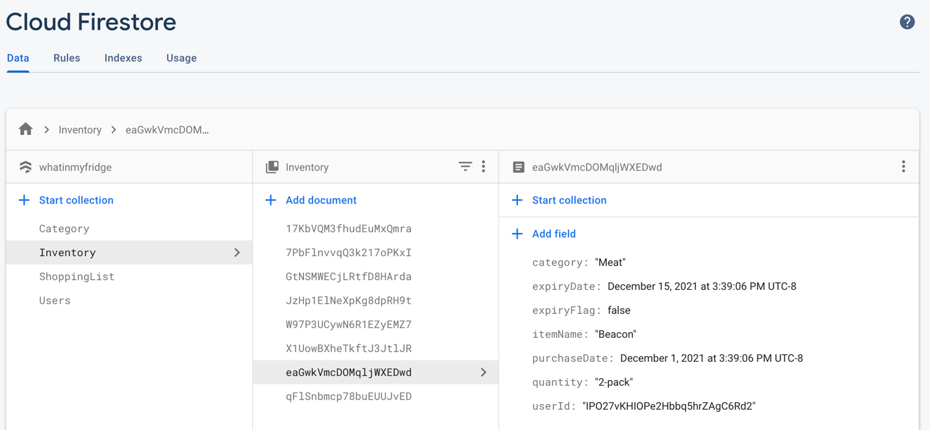

**Handling Multiple Users**

Created 2 users: Data from the Firebase Authentication. Only User email and password are added in this table so that when a user signs up using an email address and password, you can send them a confirmation email to verify their registered email address or use for validation when the user Logins in the application. This also helps multi device application as the data is stored on the cloud and not a single device.

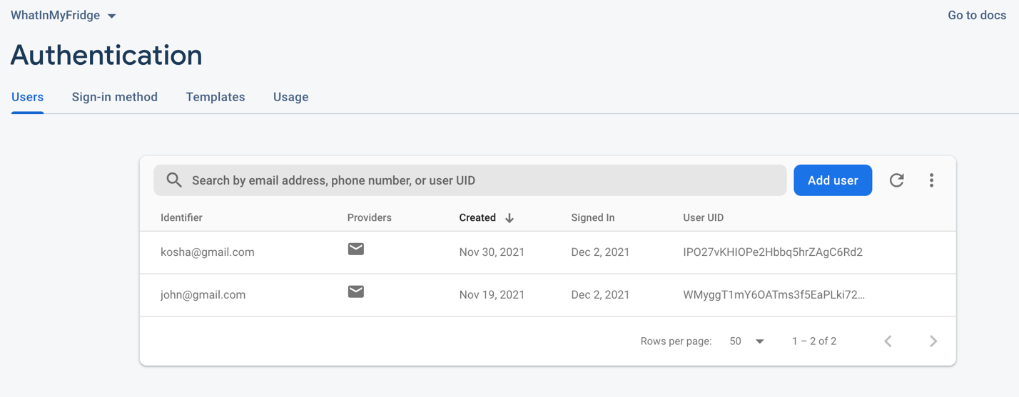

User 1:

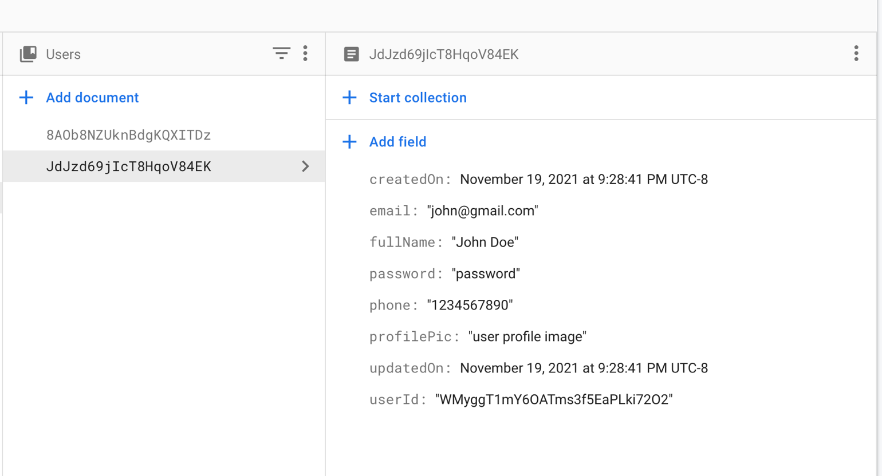

User 2:

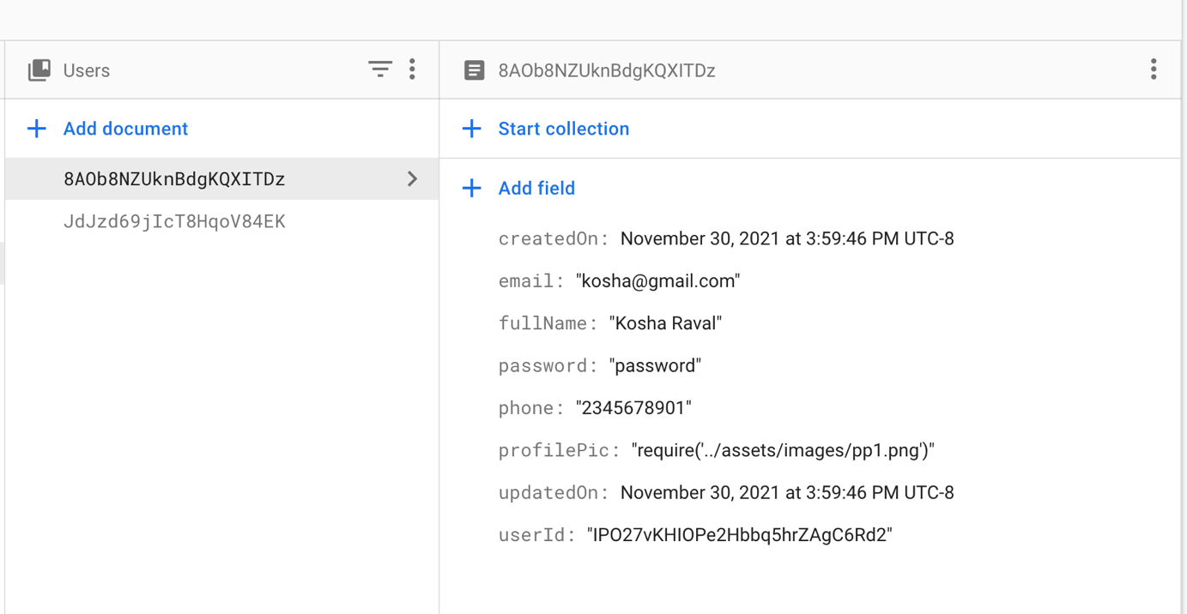

When inserting data in to the database the User-Id is to every item in the Inventory table so that when that particular user logs in, they only see they data.

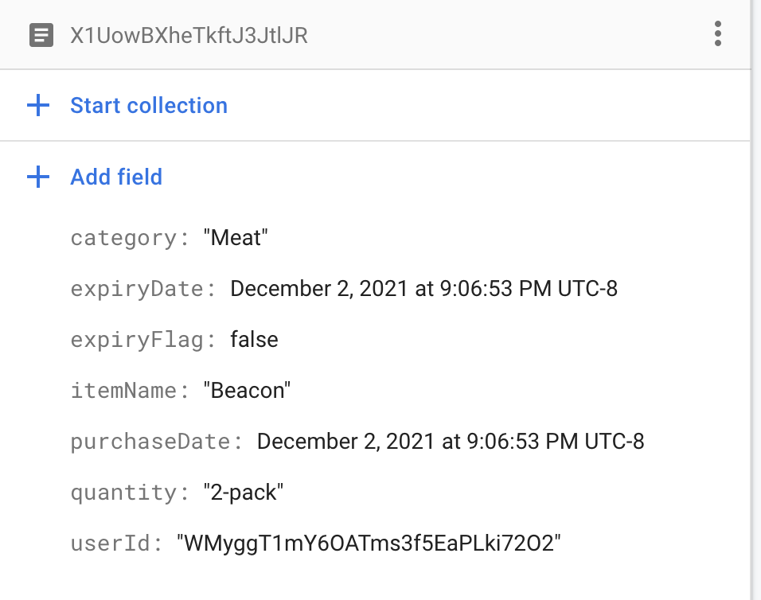

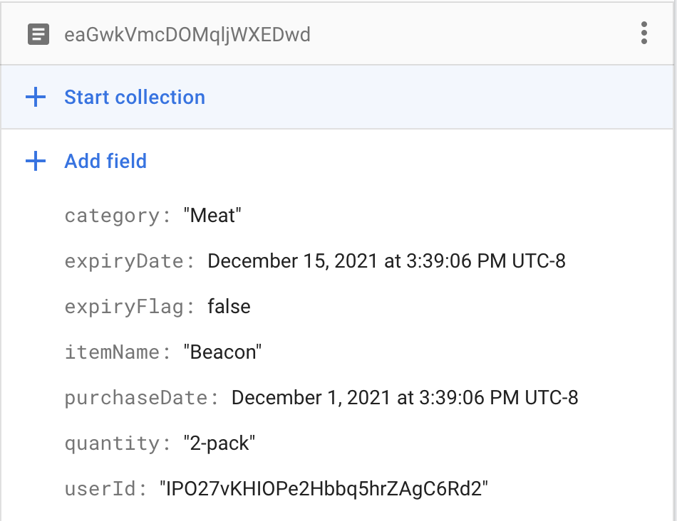

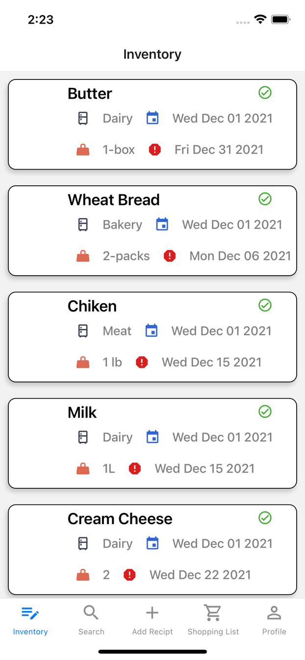 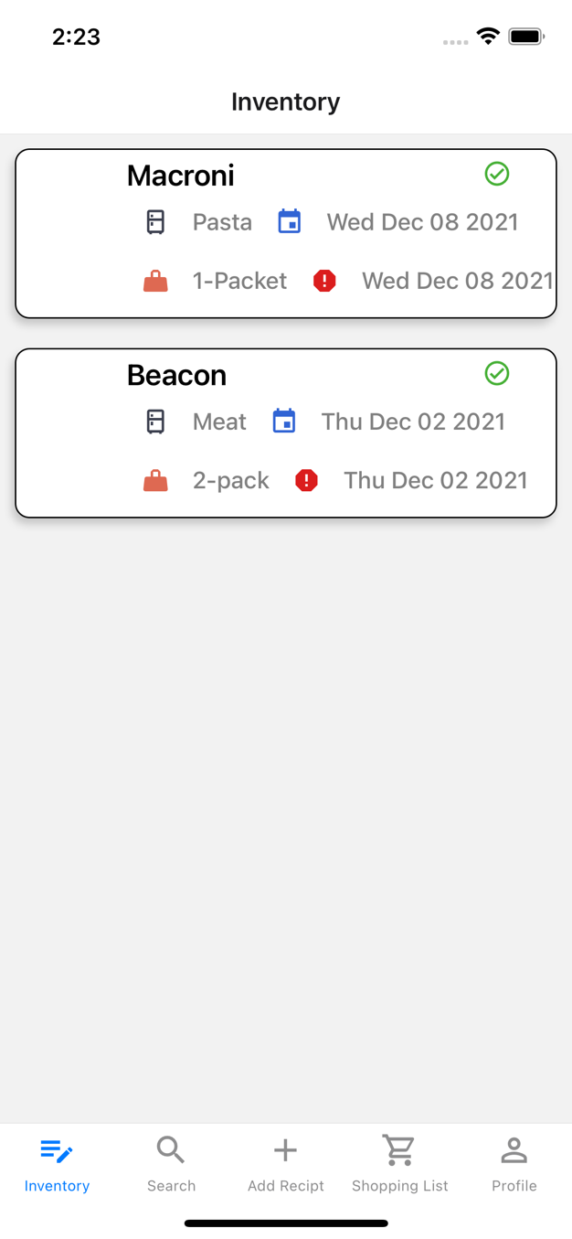

The left screen shows list of items in inventory from the user with userId: IPO27vKHIOPe2Hbbq5hrZAgC6Rd2

The right screen shows list of items in inventory from the user with userId: WMyggT1mY6OATms3f5EaPLki72O2

Citations

UI design and implementation of application React-Native:

<https://reactnative.dev/docs/getting-started>

Firbase React Native Connectivity:

<https://rnfirebase.io/firestore/usage>